K-Means And Modified K-Means Clustering Report

Contents
1. Introduction
2. Implementation and methodology
- Preprocessing and Feature Extraction
- Clustering Using K-Means and Modified K-Means
- Image Segmentation
3. Results
- Inference
4. Conclusion

Introduction
In this report, we explore the application of the K-Means (using Euclidean distance) and Modified K-Means (using Mahalanobis distance ) algorithm to segment cervical cell images. The aim is to partition each image into three distinct regions (cell body, cell boundary, and background) based on the extracted features from the images: the mean intensity and standard deviation of each patch.

Implementation and methodology

Step 1: Preprocessing and Feature Extraction
- Image Dataset:
  - The dataset consists of cervical cell images. Each image contains various regions, and we aim to segment these regions using clustering techniques.
  - For machine learning models, it's essential to extract meaningful features from the images. Directly using pixel values often doesn't capture enough contextual information about local textures or structures in the image.
- Feature Extraction:
  - 7x7 Patches: We extract overlapping patches from each image. A patch is a small window of 7x7 pixels that moves across the image with a shift of 1 pixel (meaning there is a large overlap between adjacent patches). This overlap ensures that we capture as much local detail as possible.
  - Feature Representation: For each patch, we compute the mean and standard deviation of pixel intensities. These two statistics represent the overall brightness (mean) and the local texture or variance (standard deviation) in the patch. This results in a 2-dimensional feature vector for each patch.
  - Why Mean and Standard Deviation?: These two features are simple but effective in representing the key aspects of texture and intensity variations. For example, in a region with smooth shading, the standard deviation will be low, whereas in a region with high texture (like a cell boundary), the standard deviation will be high.
  - Storage: All the extracted feature vectors are stored in .npy files, which are efficient formats for saving and loading numpy arrays.
- Training and Testing Datasets:
  - Features are extracted separately for both training and testing datasets. This ensures that the clustering model is trained on one set of images and then tested on unseen images.

Step 2: Clustering Using K-Means and Modified K-Means

2.1: K-Means Algorithm

- What is K-Means? K-Means is an iterative clustering algorithm that partitions data points into a predefined number of clusters (3 clusters in our case). Each data point is assigned to the cluster with the nearest center, and the cluster centers are updated based on the points assigned to them.
- Why not use Euclidean distance? Euclidean distance assumes that all features are equally important and independent. However, in our case, the two features (mean and standard deviation) may be correlated. For example, a region with a high mean intensity may also have a high standard deviation if it contains cell boundaries. Euclidean distance would fail to account for this relationship.

2.1.1: Steps in Standard K-Means Clustering
1: Initialize Cluster Centers
- Why is initialization important? The initial cluster centers can significantly impact the final outcome of clustering. In K-Means, the cluster centers are often initialized randomly . Both the K-means clustering methods are initialized by the same initial centres. Proper initialization can help the algorithm converge faster and avoid poor local minima.
2: Assign Points to Clusters
- How does assignment work? Each data point is assigned to the cluster whose center is closest to it. The Euclidean distance is typically used to measure the similarity between data points and cluster centers. This step helps group similar data points together based on proximity in the feature space.
3: Recompute Cluster Centers
- Why update the centers? After assigning points to clusters, the algorithm updates each cluster's center by computing the mean of all the data points assigned to that cluster. This step ensures that the center of the cluster accurately reflects the distribution of the points in that cluster.
4: Handle Empty Clusters
- What happens when a cluster is empty? In some iterations, a cluster may have no data points assigned to it (i.e., an "empty cluster"). This can occur if no points are close enough to the cluster center.
- Solution: When this happens, a typical approach is to reassign the empty cluster center to a randomly selected point from the dataset to maintain the desired number of clusters.
5: Check for Convergence
- How does the algorithm know when to stop? The K-Means algorithm repeats the assignment and update steps until the cluster centers no longer change significantly, meaning the algorithm has converged. This occurs when the change in cluster centers falls below a predefined threshold, ensuring the process terminates once stable clusters are formed.

2.2: Modified K-Means Algorithm
- What is Mahalanobis Distance? Mahalanobis distance is a generalized distance metric that accounts for correlations between features. It adjusts the distance based on the covariance of the features, making it more effective when features are not independent (which is often the case with image features).
- Why use Mahalanobis Distance? In our image patches, the mean and standard deviation are likely correlated. For example, a patch that is part of a textured region (with a high standard deviation) may also have a specific brightness level (mean). Mahalanobis distance helps capture this relationship, resulting in better clustering.

2.2.1.: Steps in Modified K-Means Clustering
1: Initialize Cluster Centers
- Why initialize randomly ?: The initial placement of cluster centers can affect the final clusters. Random initialization helps explore different regions of the feature space. Both the K-means clustering methods are initialized by the same initial centres.
- Note: using precomputed centers (e.g., from standard K-Means) can speed up convergence if the clusters are already well-separated.
2: Assign Points to Clusters
- How does the assignment work? For each patch's feature vector, the Mahalanobis distance is computed to each cluster center. The patch is assigned to the cluster with the smallest distance. This step groups similar patches together based on how they relate to the overall feature distribution.
3: Recompute Cluster Centers
- Why update the centers? Once all patches are assigned to clusters, the cluster centers are updated by taking the mean of the feature vectors in each cluster. This step refines the clusters, ensuring that the center represents the actual data points in the cluster.
4: Handle Empty Clusters
- What happens if a cluster is empty? Sometimes, no points are assigned to a cluster (an "empty cluster"). This can cause problems during the covariance matrix computation, as we can't calculate the covariance of an empty set.
  - Solution: If a cluster becomes empty, we randomly assign a new point from the dataset as the cluster center. This ensures that all clusters remain active throughout the iterations.
5: Check for Convergence
- Why check for convergence? The algorithm iterates until the cluster centers no longer change significantly. Once the centers stabilize (i.e., the change is below a certain threshold), the clustering process is considered complete. This ensures that the algorithm doesn't keep running indefinitely.

Step 3: Image Segmentation
Once the clustering model is trained, we can apply it to segment the test images based on the learned clusters.
3.1: Load Test Image Features
- Why use test images? We want to evaluate the model's performance on unseen data to ensure that it generalizes well beyond the training set. This is a key principle in machine learning—avoiding overfitting.
3.2: Assign Test Patches to Clusters
- How does the assignment work? For each patch in the test image, we compute the using Euclidean distance( in case of K-Means) and using Mahalanobis distance( in case of Modified K-Means ) between the patch's feature vector and the cluster centers learned during training. The patch is assigned to the nearest cluster.
3.3: Reshape Cluster Assignments into an Image
- Why reshape the cluster assignments? The clustering algorithm works on individual patches, but we need to represent the result as a segmented image. After clustering, we reshape the cluster labels into the same grid structure as the original image, with each patch colored according to its cluster.

Results
Below are the results of K-Means (using Euclidean distance) and Modified K-Means (using Mahalanobis distance ) algorithm applied to the cervical cell images.

The plot below shows the result of K-Means clustering on the training data.

The plot below shows the result of Modified K-Means clustering on the training data.
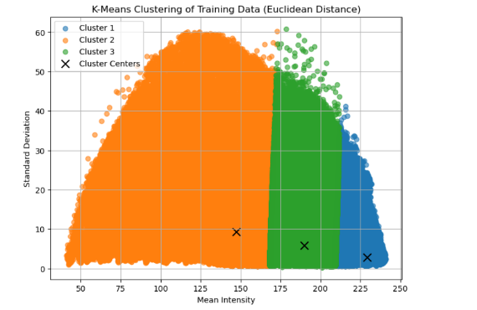
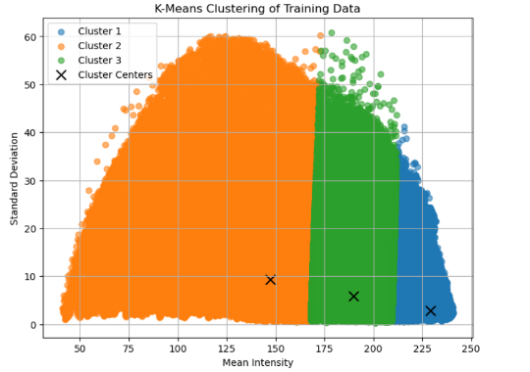

Modified K-Means : Figure 2

K-Means : Figure 1

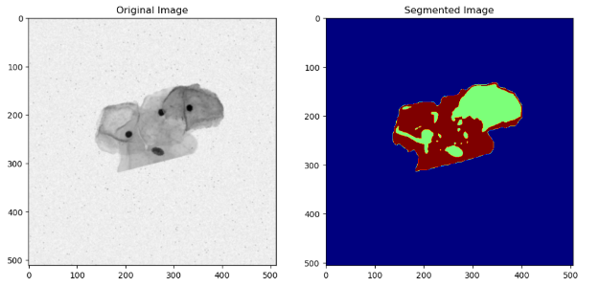
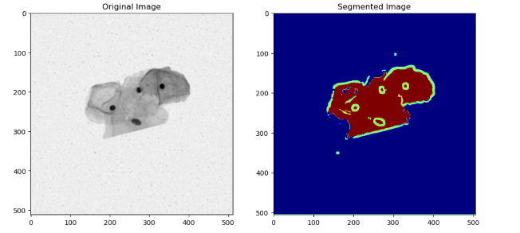

Modified K-Means : Figure 4

K-Means: Figure 3

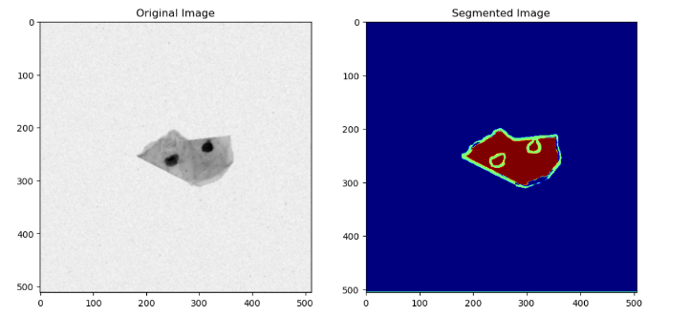
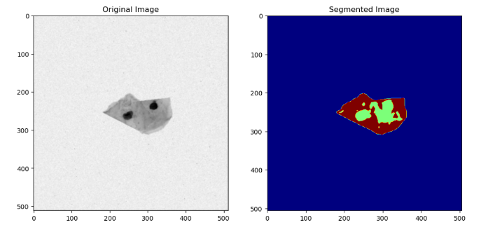

Modified K-Means : Figure 6

K-Means: Figure 5

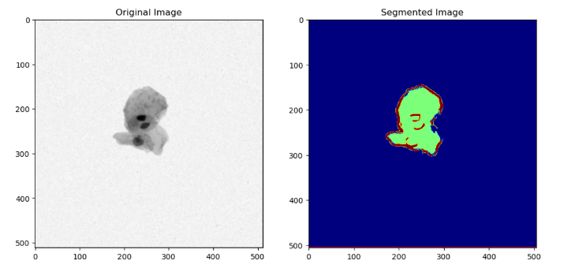
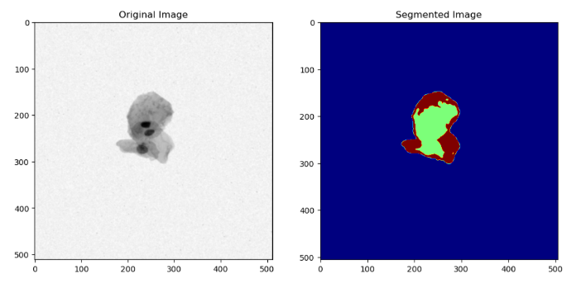

Modified K-Means : Figure 8

K-Means: Figure 7

Inference

Inference ( K-Means: Figure 1)
- Cluster 1 represents patches with lower mean intensity but higher variance, potentially corresponding to the cell boundary.
- Cluster 2 captures patches with medium intensity and medium variance, likely corresponding to the cell body.
- Cluster 3 captures patches with higher intensity but lower variance, likely corresponding to the background.
- The separation between clusters demonstrates the effectiveness of feature extraction in separating different regions of the cell image.

Inference (Modified K-Means : Figure 2)
- The training data clusters are well-defined in terms of their respective mean intensities and standard deviations. Cluster 1 (blue) represents patches with relatively high standard deviation and high mean intensity, which may correspond to cell interiors. Cluster 2 (orange) shows patches with medium standard deviation but low mean intensity, corresponding to background or noise. Cluster 3 (green) likely represents cell boundaries with medium to high mean intensities and standard deviations.

Inference ( K-Means: Figure 3)
- In this image, the clustering has segmented the regions of interest, with cluster 1 (light green) representing the inner cell regions, cluster 2 (brown) marking cell boundaries, and cluster 3 (blue) indicating the background. The segmentation effectively distinguishes the cell structure from the background.

Inference (Modified K-Means : Figure 4)
- The segmentation successfully isolates the cell body from the background and the cell boundary.
- The dark circular regions in the cell image, likely corresponding to the cell nuclei, are clearly separated from the lighter regions.
- The boundaries of the cell are accurately captured, reflecting the model's ability to handle subtle texture differences

Inference ( K-Means: Figure 5)
- In this image, the clustering has successfully identified the distinct regions. The segmentation highlights the cell interiors with cluster 1, while the cell boundaries are marked by cluster 2. Cluster 3 segments the background.

Inference (Modified K-Means : Figure 6)
- The segmentation clearly distinguishes between the cell body, boundary, and background in the smaller cell image.
- The boundaries are well-defined, and the clustering method proves effective even on smaller image areas.
- The model successfully identifies the prominent structures within the image, reflecting robustness to varying cell sizes.

Inference ( K-Means: Figure 7)
- In this image, K-Means clustering has effectively separated the cell regions from the background. Cluster 1 highlights the primary cell area, while cluster 2 emphasizes cell boundaries and cluster 3 isolates the background. The segmentation is clear and accurate.

Inference (Modified K-Means : Figure 8)
- This segmentation result shows clear separation between the cell body and the background.
- The cell boundary is highlighted effectively, and small structures within the cell are captured in detail.
- The segmentation accurately reflects the complexity of the cell image, demonstrating the method's ability to handle fine image details.

Conclusion
- In conclusion, both K-Means and Modified K-Means clustering algorithms effectively segment cervical cell images into three regions. While K-Means clustering using Euclidean distance provides clear segmentation, Modified K-Means with Mahalanobis distance offers superior performance in distinguishing cell boundaries and handling correlations between features. This makes Modified K-Means a better choice for complex image segmentation tasks, as demonstrated in the results.

